- Purpose
  - The purpose of this document is to describe the procedure for assembling the handle on the Orbital Strip Machines.
- Scope
  - This SOP applies to all equipment assembly team members. The process applies to the following machine ID’s:
E012801EQM0600BA1000 – Basic Sand Dragon, 20”
E012801EQM0607BE1200 – Crewman ORB 20
E012801EQM0607BA1200 – Basic Sand Dragon 20, Canadian
E012801EQM0607BE1200 – Crewman ORB 20, Canadian
E012806EQM0600BA1000 – Basic Sand Dragon, 20”, w/ Weights
E012806EQM0600BE1200 – Crewman ORB 20, w/Weights
E012806EQM0607BA1200 – Basic Sand Dragon 20, w/Weights, Canadian
E012806EQM0600BE1200 – Crewman ORB 20, w/Weights, Canadian
E012811EQM0600BA1000 – Basic Sand Dragon, 28”, w/Weights
E012811EQM0600BE1000 – Crewman 28 ORB, w/Weights
E012811EQM0607BA1200 – Basic Sand Dragon 28, w/Weights, Canadian
E012811EQM0607BE1200 – Crewman ORB 28, w/Weights Canadian
- Responsibilities
  - The operations manager/supervisor is responsible for enforcing this SOP.
- Materials
  - The proper materials needed for this process are listed on the machine work order.
  - Hand/Power Tools
- Definitions

- Procedure
  - Insert a rubber grommet (83519) over the handle cord (83132). Slide it down towards the plug end.

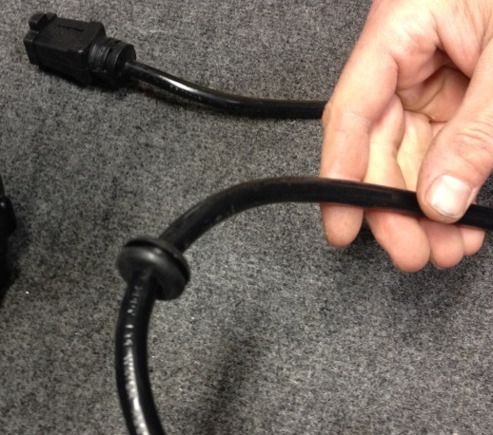
  - Feed the handle cord into the handle tube (89688). Pull the harness through until a length approximately the same as shown sticks out of the top of the tube.

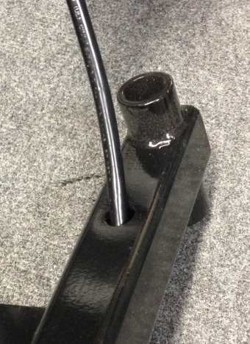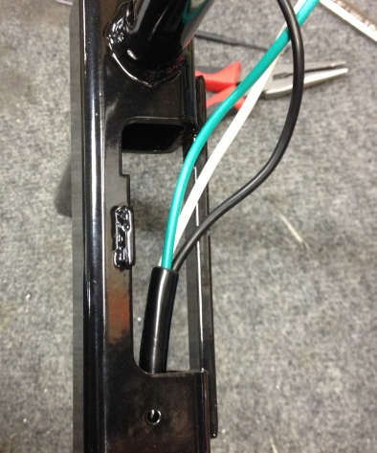

  - Use a small screwdriver to assist and tuck the inner flange of the grommet inside of the handle tube.

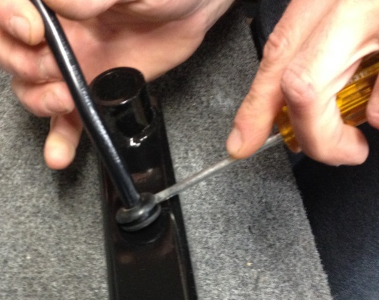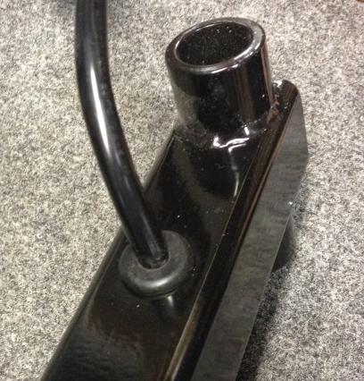

  - Take an extension spring (83130) and loop it over the tab on a spring clip (83270). Use a pair of pliers to smash down the tab so that the spring does not fall off. Repeat for a 2nd set.

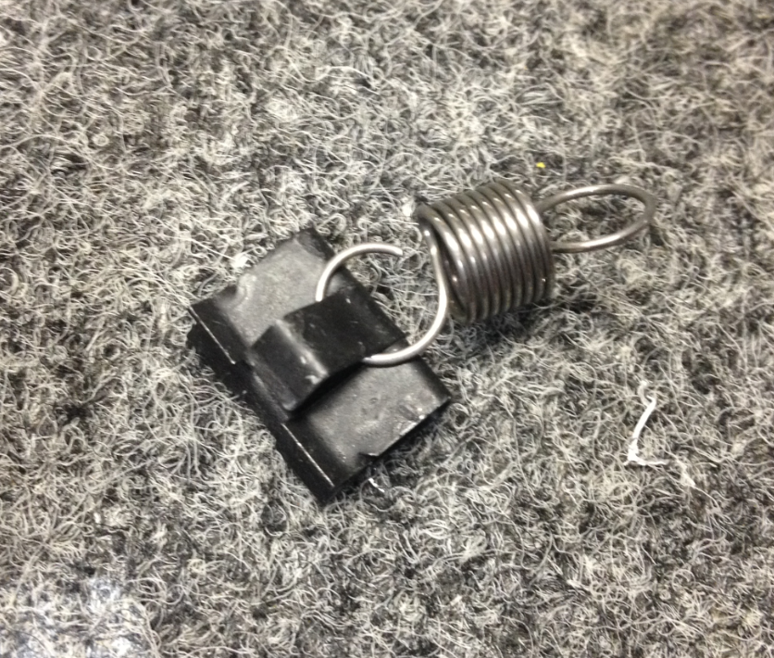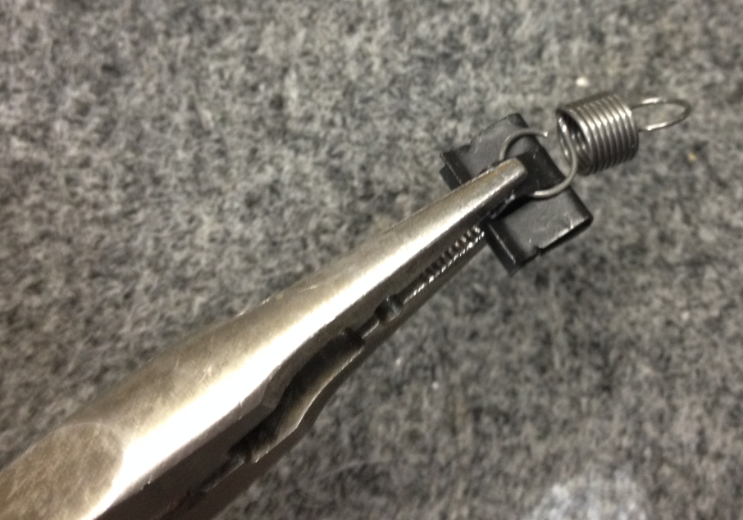

  - Install each of the spring clips into a front handle cover (89687) onto the ribs shown. Be sure that the orientation is correct.

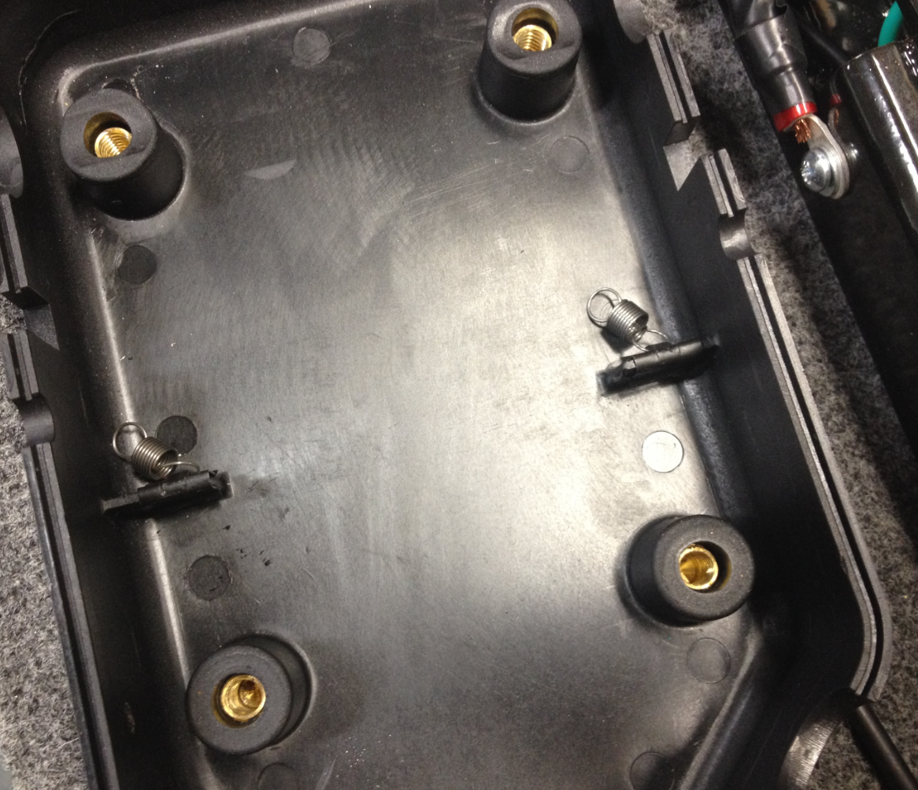
  - Place the switchbox onto the bottom side of the handle as shown.

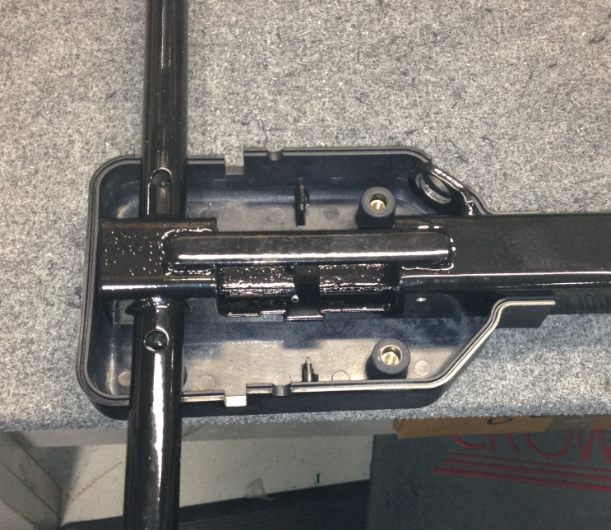

  - Dis-assemble the end of a metal strain relief (89602) and pull the sleeve out. Install the spring portion and the sleeve over the main power cord (83790 for a 20” machine and 89889 for a 28” machine) in the orientation shown. Tighten the components of the strain relief. Ensure that the connection is tight to be sure that the sleeve on the inside bites onto the cord.

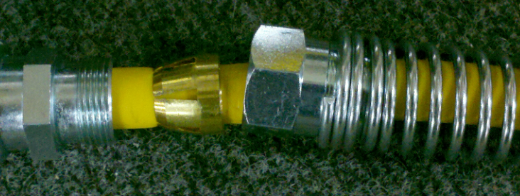
Sleeve
  - Install the strain relief into the switchbox as shown. Thread a metal strain relief nut (83789) onto the end of the strain relief threads with the teeth facing the metal bracket.

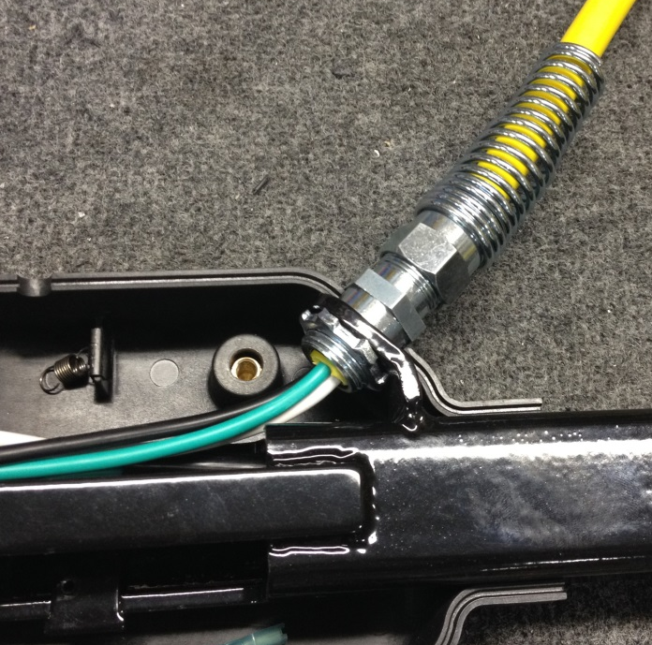

  - It may be easier to remove the back handle cover for the next few steps. This is a preference thing.

  - Connect the two white wires using a wire nut (83522). Tuck the wire down into the handle tube.

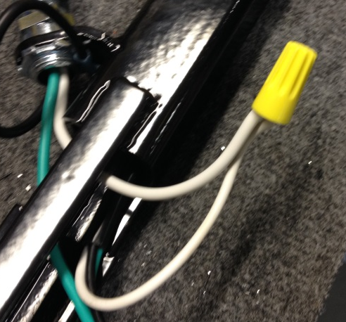

  - Connect the green wire from the handle cord, the green wire from the power cord, and a green jumper wire (83521) with a wire nut (83522).

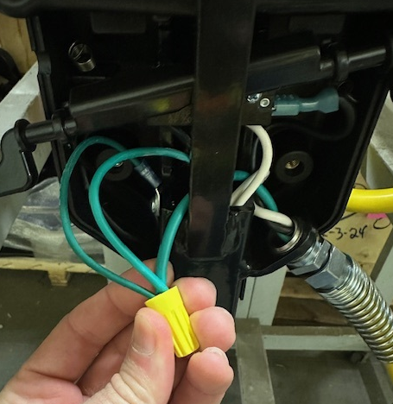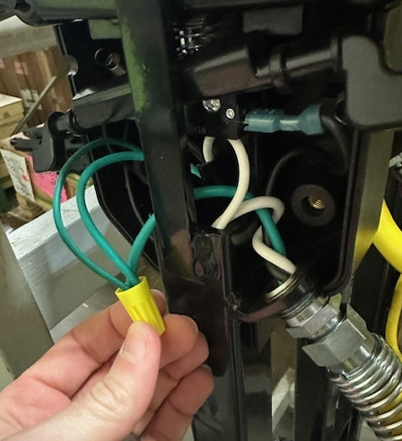

  - Use a screw (88696) and a washer (11420) to connect the ring terminal from the jumper wire to the hole in the handle. If the back handle cover was removed, put it back in place now.

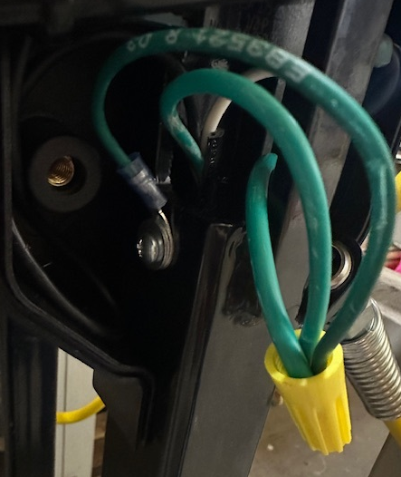

  - Locate a left switch lever (89916) and the right switch lever (89917). These will need to be dry fitted to verify that they function properly. Note the orientation below.
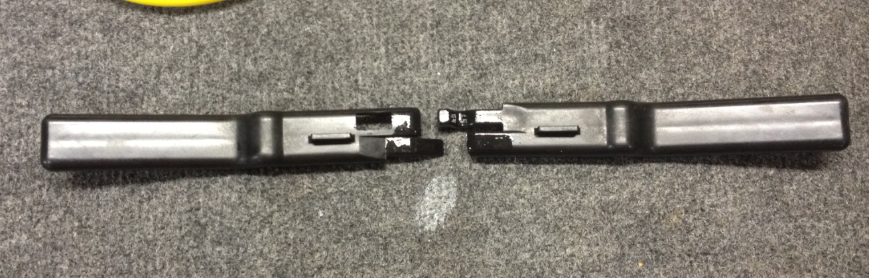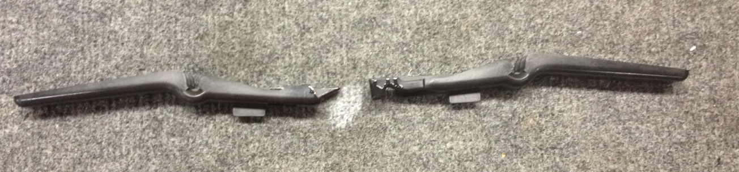
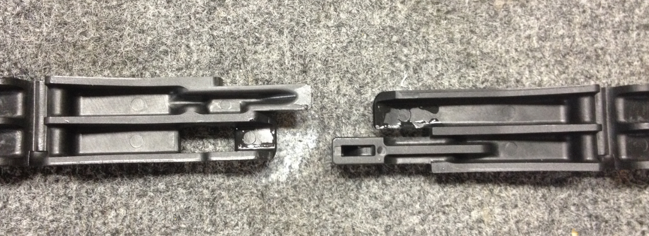
  - Interlock the two pieces as shown. This will require a slight scissor motion.

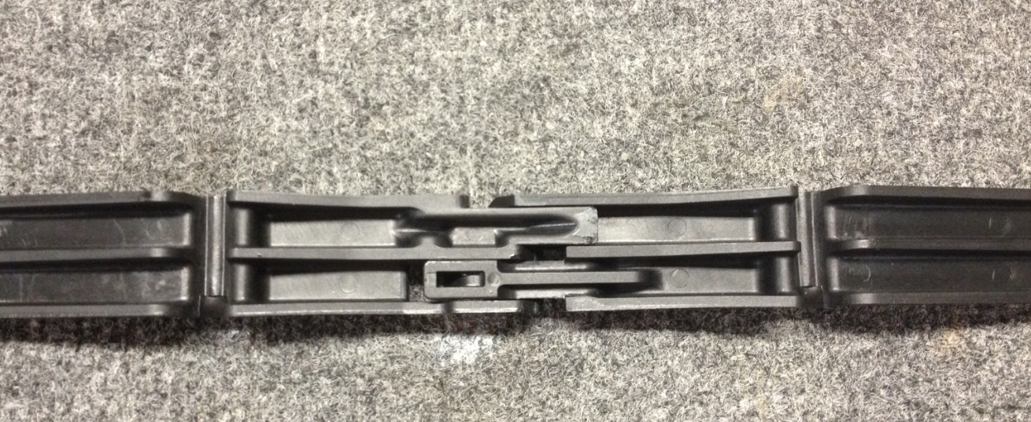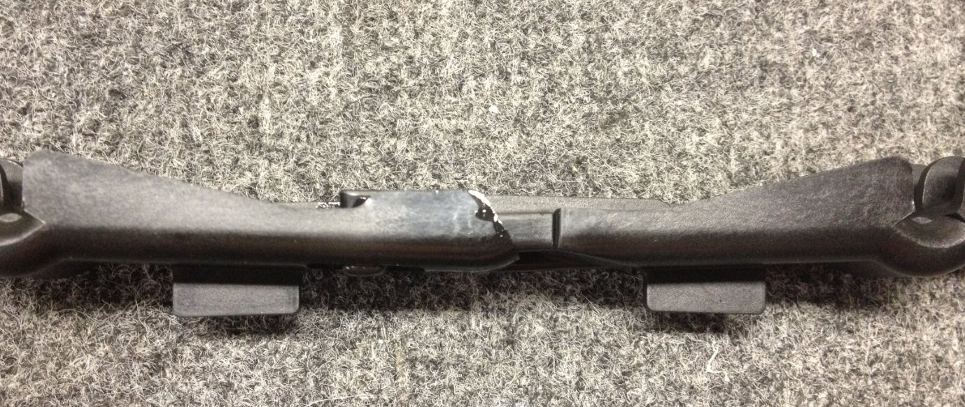
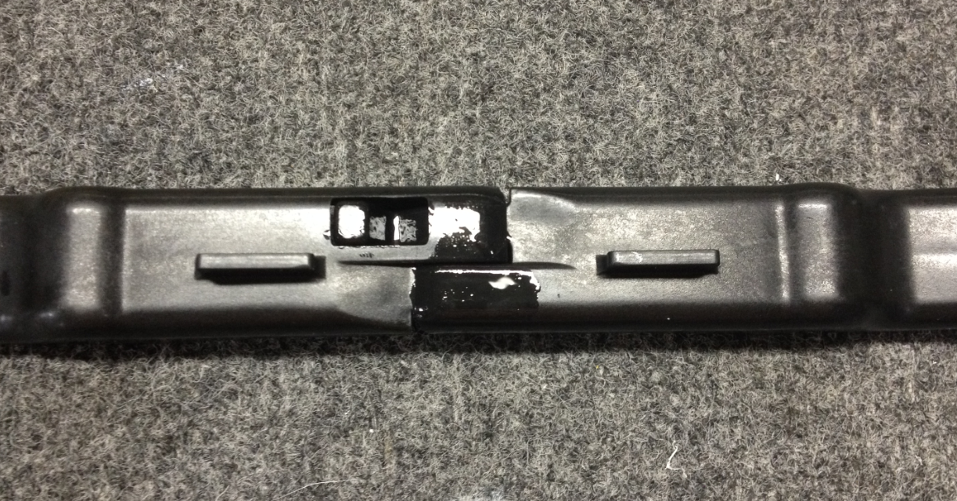

  - Rotate the two pieces up and down to make sure that they slide freely and without catching. If they catch, there are 2 things that can be done. Take a knife and remove any flashing from the top edges of the parts. Apply a very light coating of silicone grease onto the sliding surfaces. Once the pieces move properly, proceed to the next step.

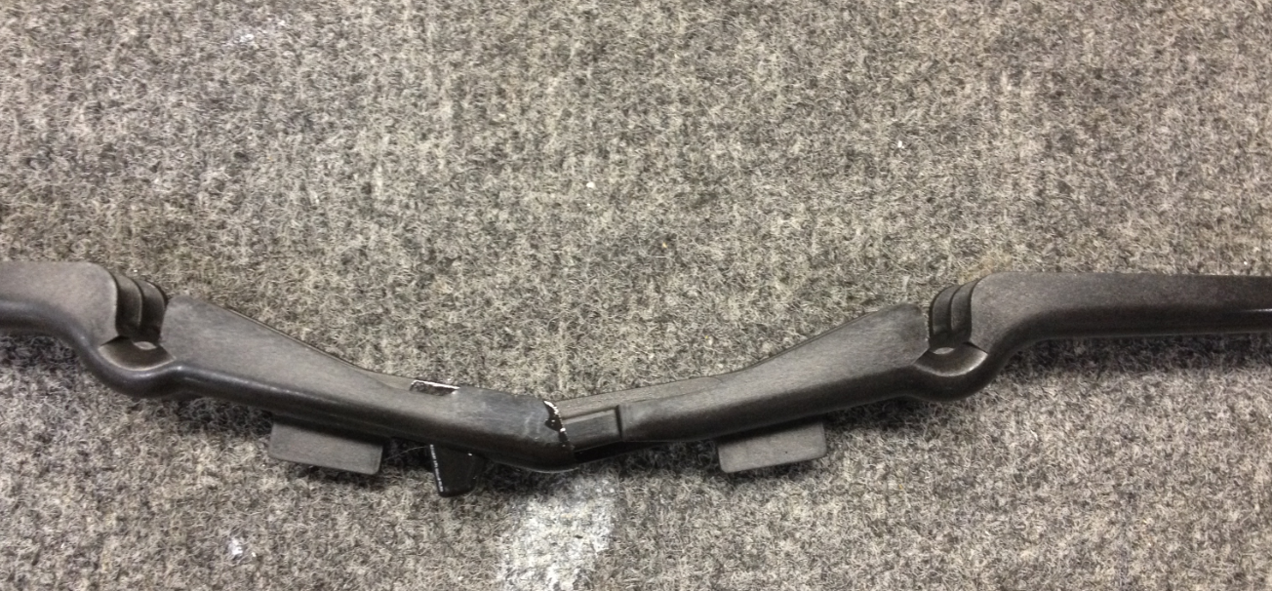
De-flash edges if needed
  - Orient the trigger to the handle as shown.

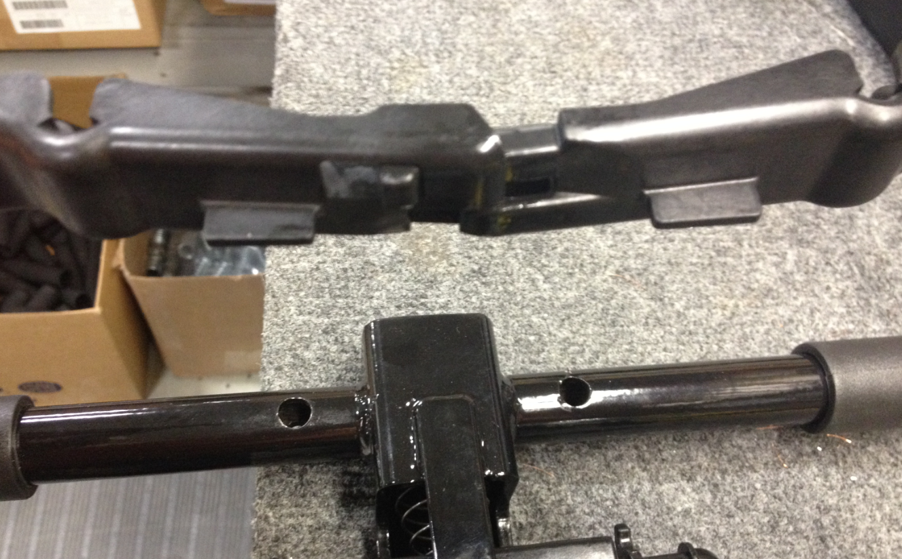

  - Feed the trigger assembly through the handle as shown. You may need to slightly lift the handle out of the switch box. The trigger will then rest in the grooves on the switch box.

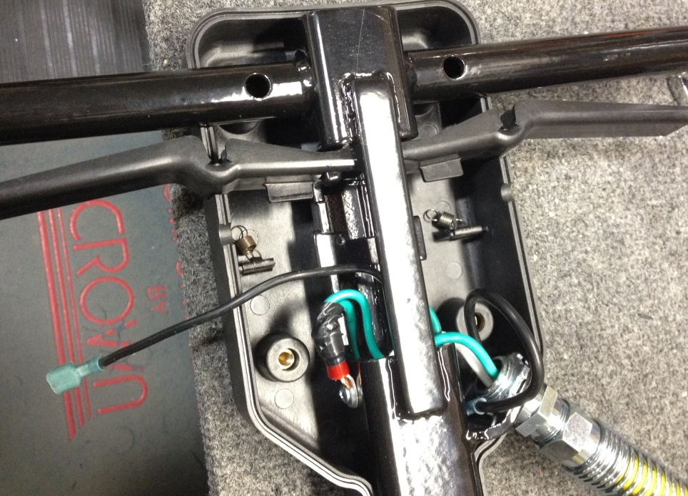

  - Feed a safety lock (89918) through the handle. Note the orientation. It will rest in the grooves on the switch box.

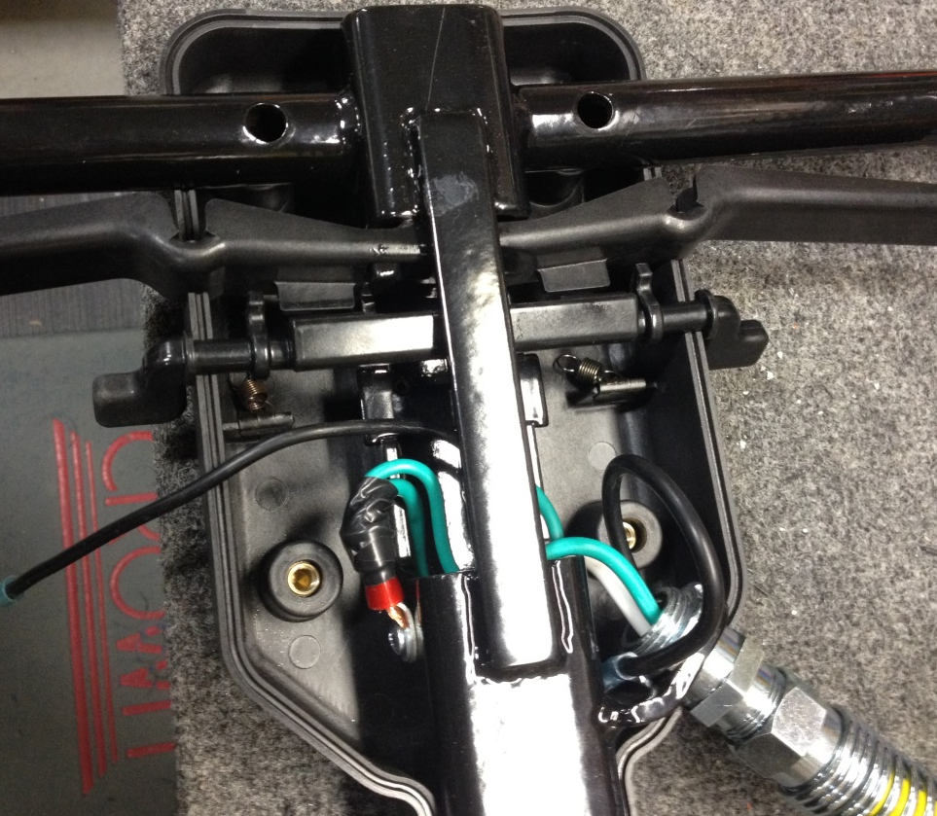
  - Take a conical spring (89919) and thread it onto the trigger switch. Simply twist it onto the threaded portion of the switch (85032).

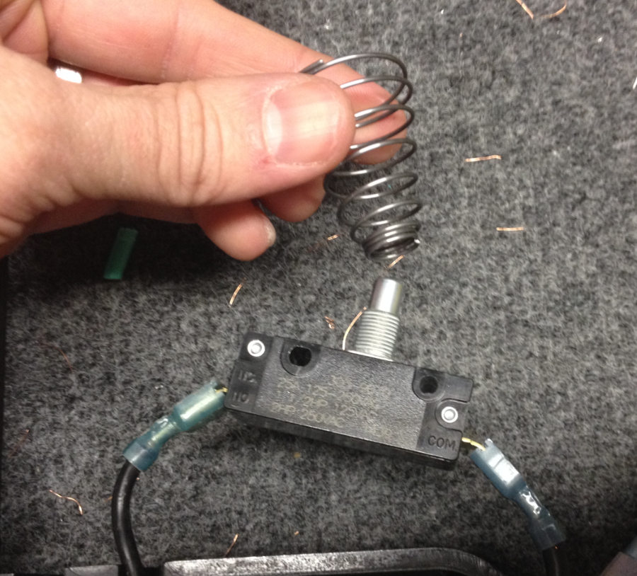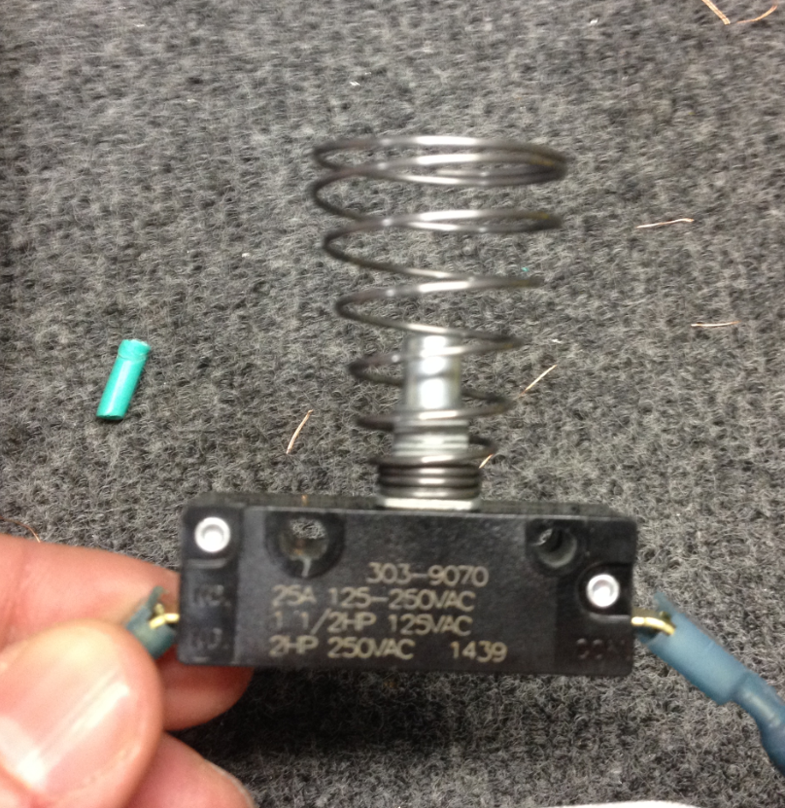
  - Slide the switch into the assembly as shown. The spring will go behind the safety lock and then rest against the trigger switch.

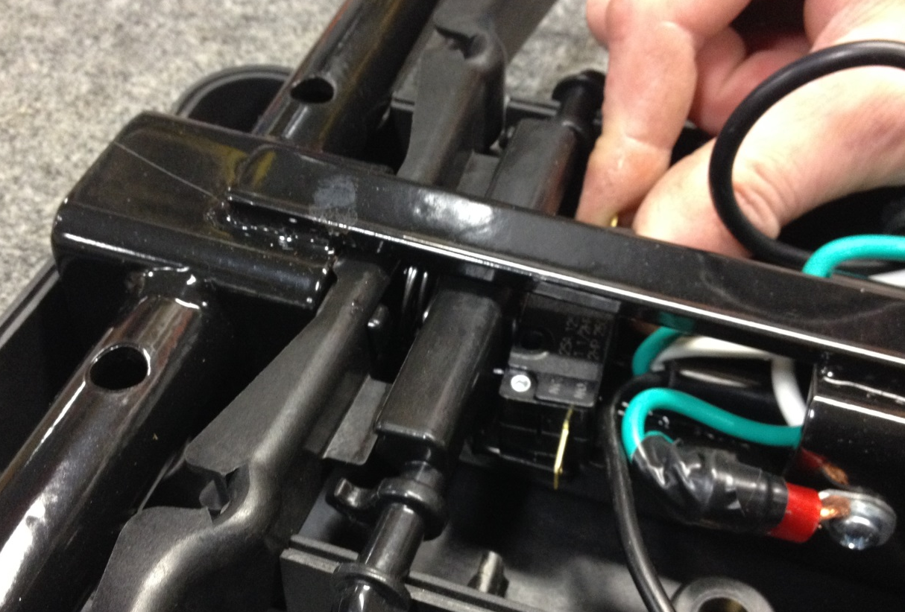
Spring

  - Once in place, fasten the switch to the handle using 2 screws (89900).

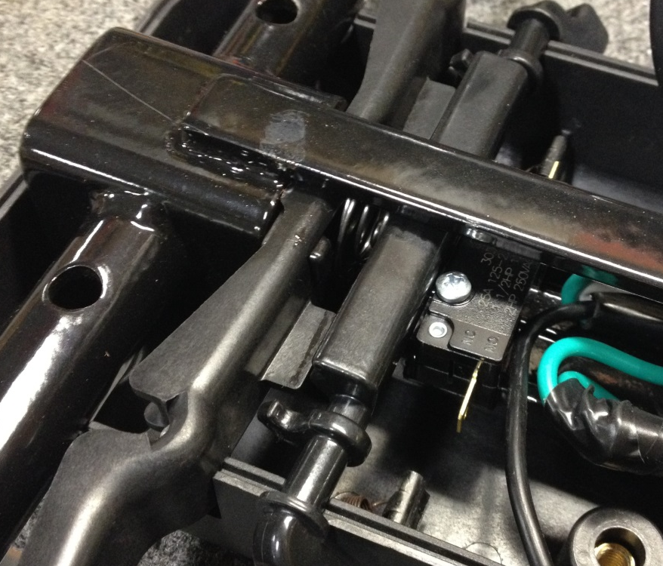

  - Connect the black wires to the switch as shown. The black wire from the yellow power cord goes to the right side and the wire from the handle cord goes to the left side. Tuck the excess wire into the handle.

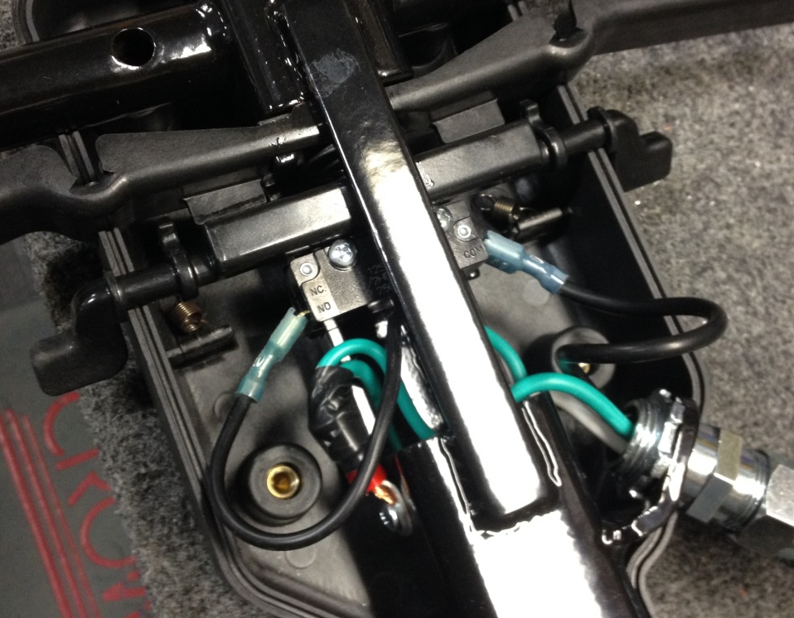
  - Each of the springs needs to be stretched under the safety lock and around the finger shown. This is best done using an o-ring pick or equivalent. If none are available, needle nose pliers will need to be used.

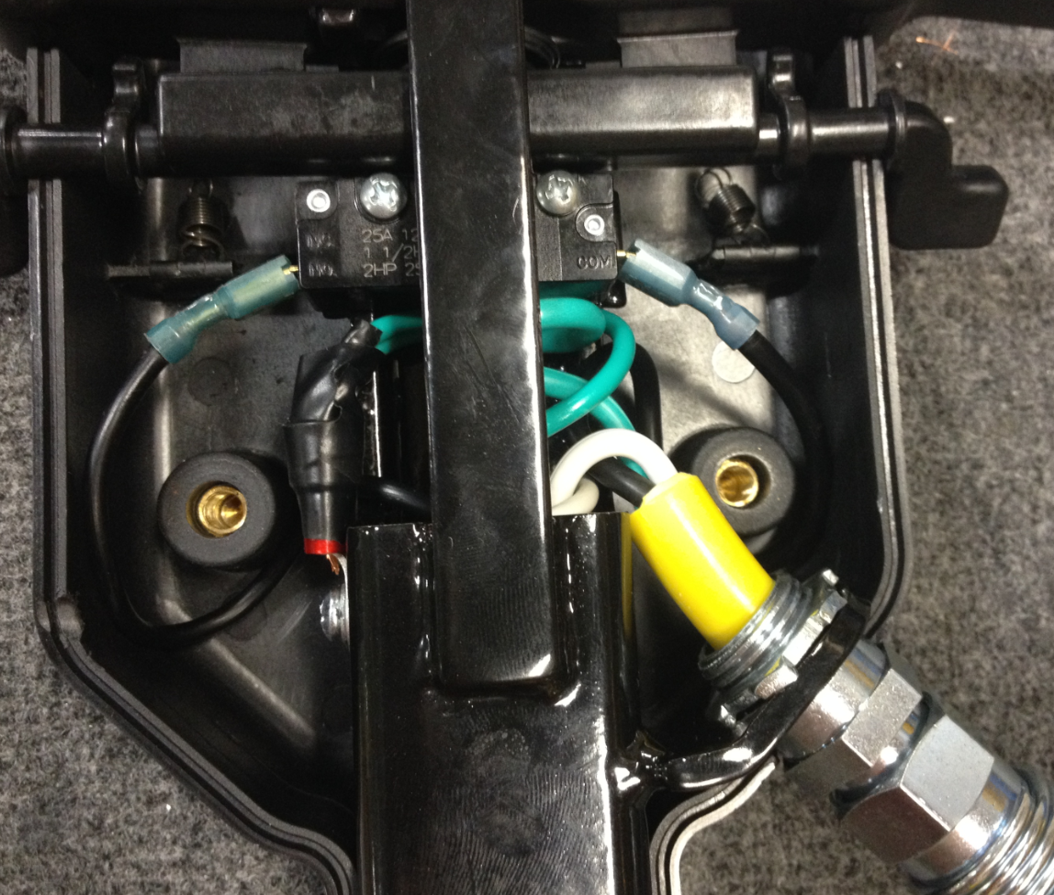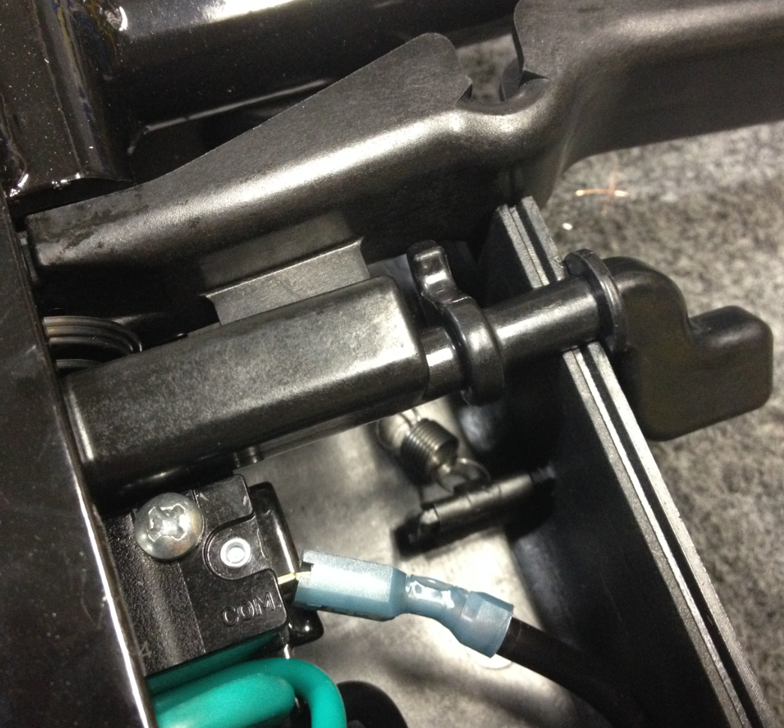
Spring will pass under the safety lock here
Spring will loop over this finger
  - Grab the loop on the spring and rotate the finger of the safety lock downwards so that the loop on the spring can be placed over it. Rotating the finger down decreases the distance that the spring needs to be stretched and makes installation much easier.

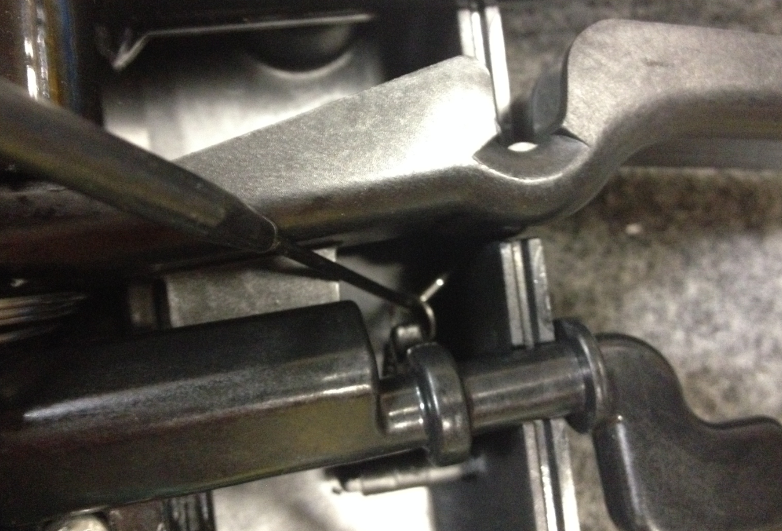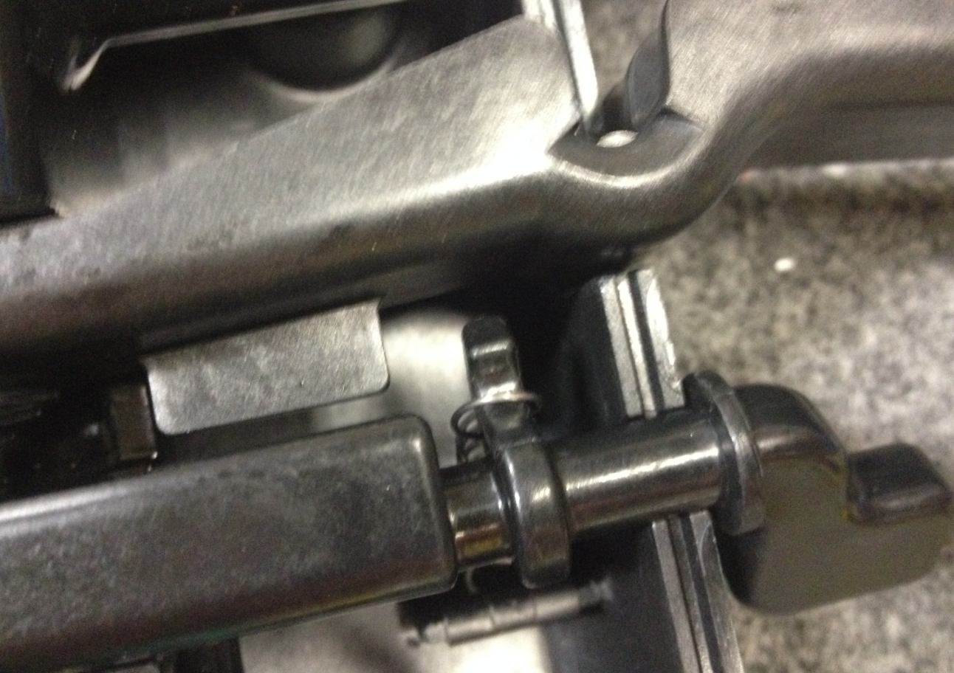
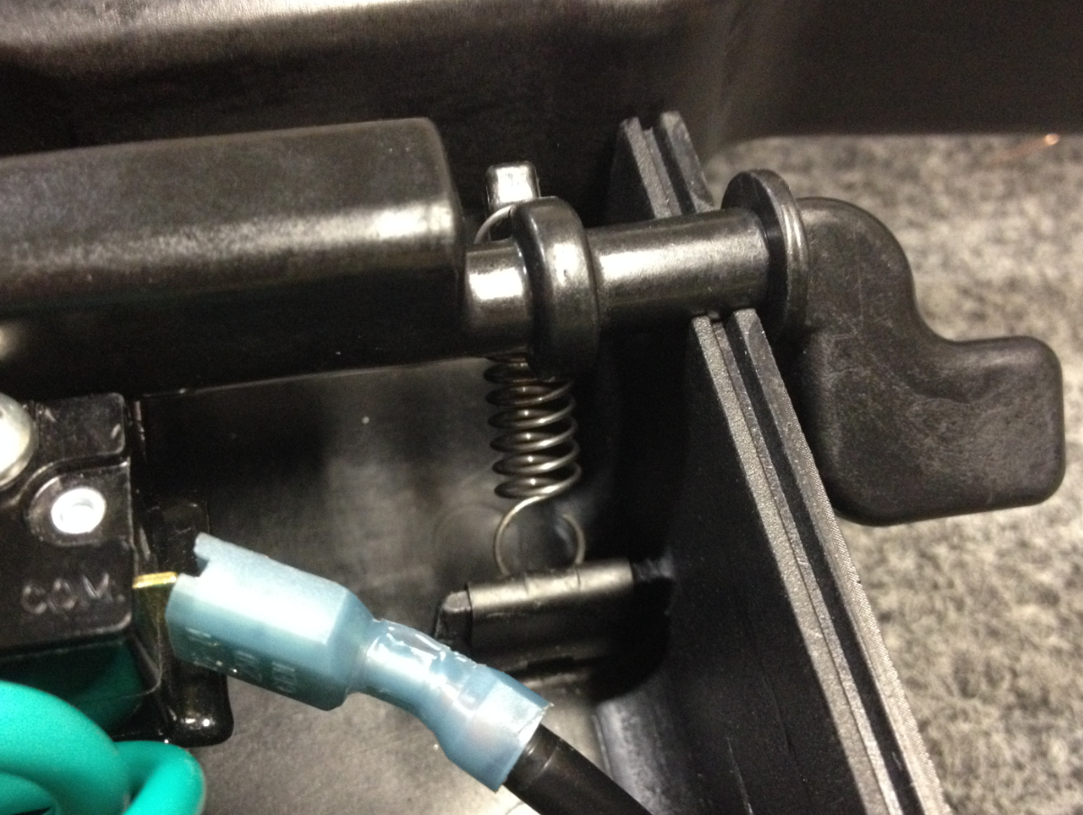
  - For all remaing steps, please be sure that the safety lock is not allowed to rotate freely since there is spring pressure being applied. This will cause it to spin and the spring will pop off. Keeping a finger on the safety lock will help keep it still.
  - Repeat the installation for the opposite spring. When rotating the safety lock so that the spring can be looped over the finger, use your other hand to make sure that the opposite spring does not come off.

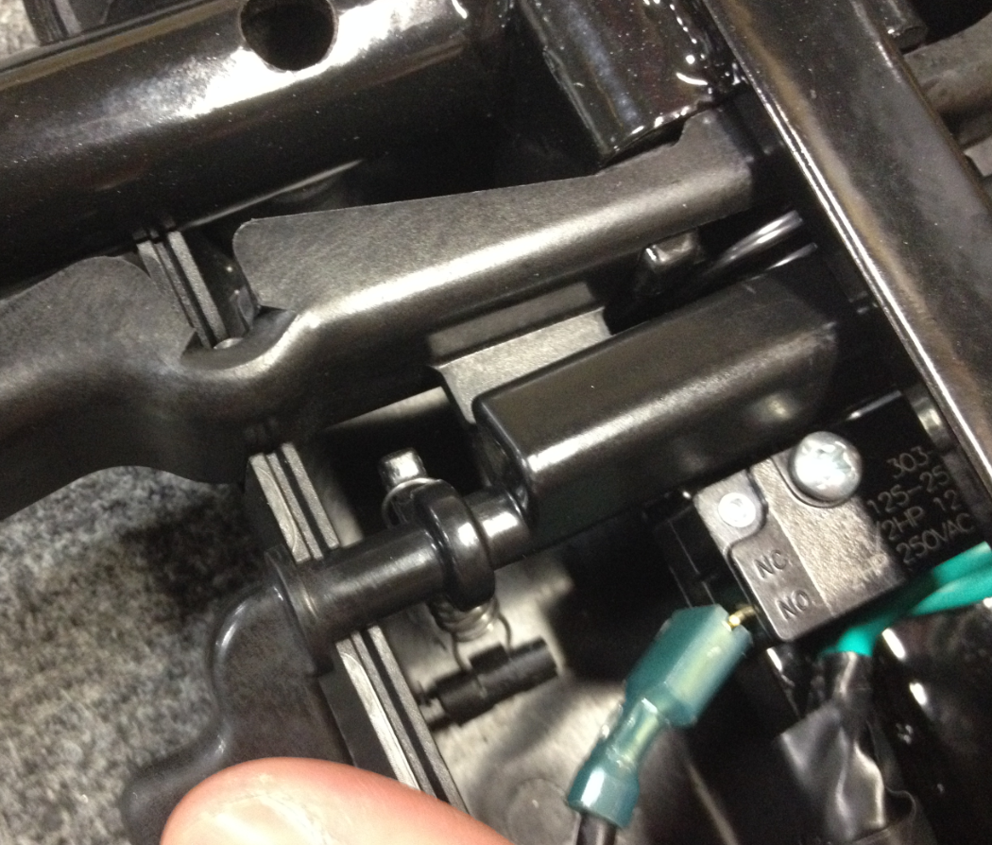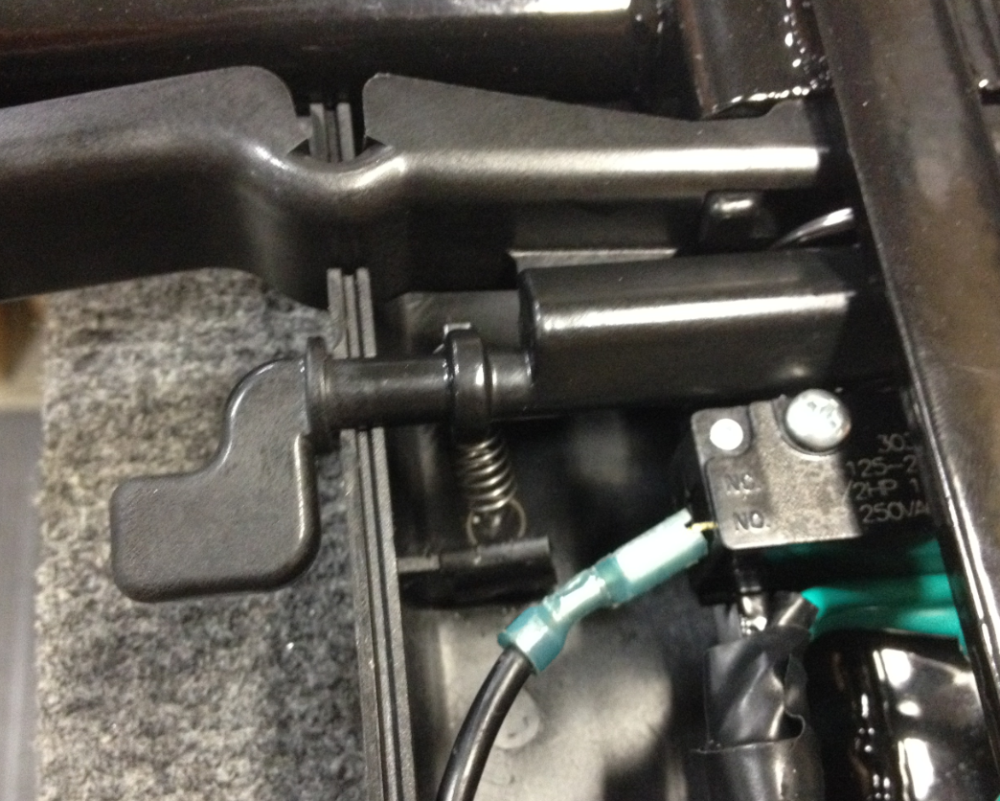

  - Hold the safety lock so that it does not pop out of the groove.
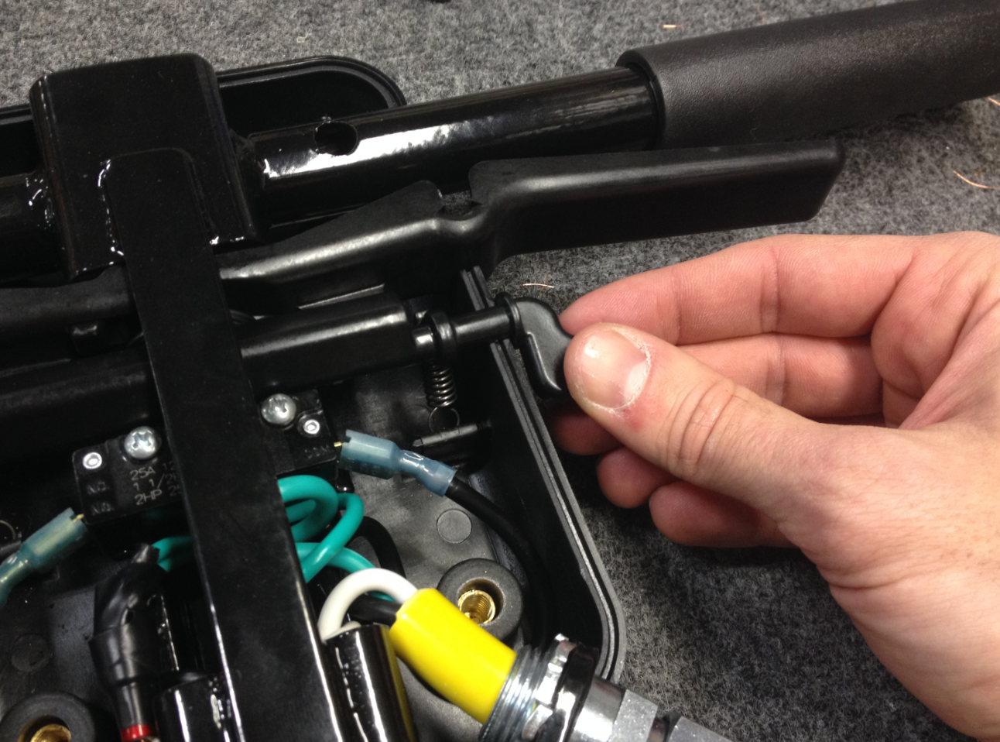

  - Place the switch box cover (89688) over the back of the box. Fasten the cover on using 4 of screw (83426).

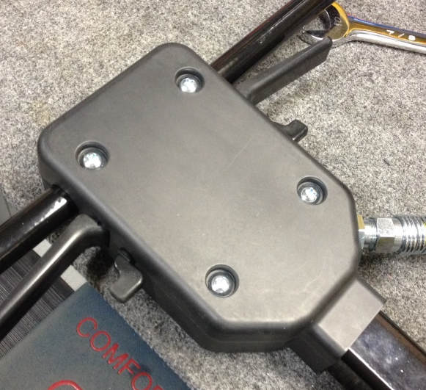

  - Place the safety decal (83691) on the back of the handle cover.

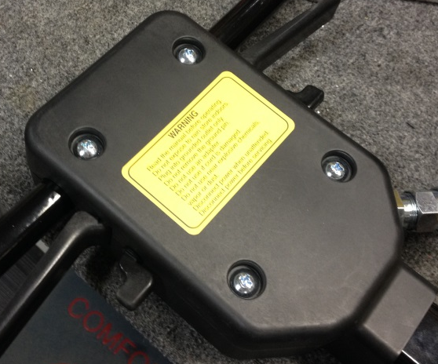

  - Slide the handle grips (89691) into place.

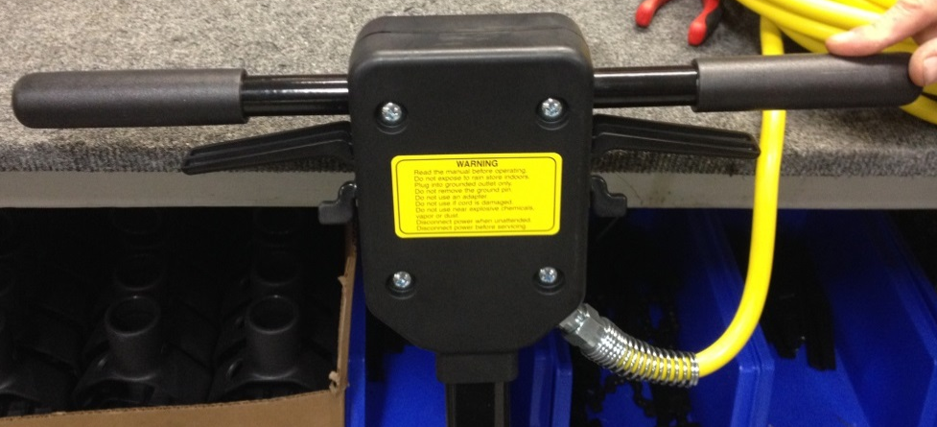
- References (optional section as needed)

- Training Guide

Functional Training Groups Requiring Training
Equipment Assembly Group

- SOP Change Control

Date of Change | Reason for Change
Rev 01 - 4/28/2015 | This is the first version of the S.O.P. hence there are no revisions to this document.
Rev 02 - 1/16/2018 | Added Responsibilities section and added in process quality check.
Rev 03 - 5/4/2018 | Updated to reflect the Orbital Upgrades
Rev 04 - 3/6/2025 | Removed work center call out and updated ground wire steps

Approvals

Submitter/Author Approval:__________________________________ Date:______________________

Management Approval:______________________________________ Date:______________________

QAU Approval:_____________________________________________ Date:______________________

